1. display all players playerid, player name and experience

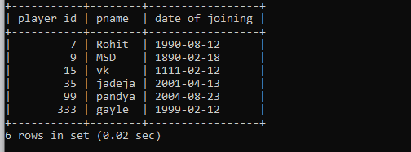

1. display all player with experience > 5 years

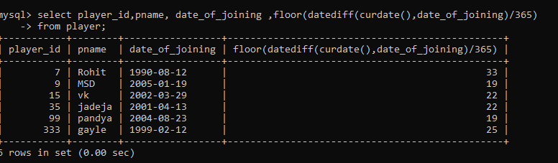

1. display all players joined in march month, any year

4. display all players joined in march 1995

5. display all player with number of matches played are either 5 or 10 or 8

6. display all employees who are either batsman, bowler

7. display all employees who joined in year 1995 or 1996 or 1997